How to use PmodCLP

Objective
The goal is to demonstrate the operation of PmodCLP (LCD module).
In this demonstration we incorporate the LCD and the divider core designs together and display a dividend, a divisor, a quotient and a remainder on the LCD. The user inputs the dividend and the divisor using 8 switches (4 switches for each) and the range of the dividend and the divisor is 0-15 (1 hexadecimal number). Also we can see how numbers on the LCD dynamically change as the divider operation goes on. Last, I will explain the LCD core design briefly.

Short description
The PmodCLP is a 16x2 character LCD module that uses two Pmod connectors to present a 3.3V, 8-bit parallel data interface to system boards. It is based on a Sun like LCD panel that uses a Samsung KS0066 LCD controller. The module can be attached to any number of Digilent system boards to create a character LCD subsystem.
There are two versions of PmodCLP, rev. A and rev. B, and only rev. B is workable with Nexys-3 board.
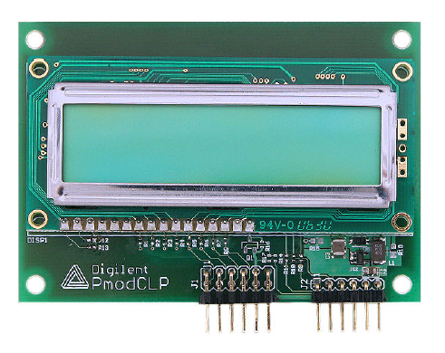

How to run the demo project and incorporate the LCD core design with your own project

Step 1: Create a new project and add the following files:
- lcd_core.v (LCD core design)
- divider_combined_cu_dpu_with_single_step.v (Divider core design)
- divider_top_LCD.ucf

The file divider_combined_cu_dpu_with_single_step.v is only needed for this demo project. You can use any core machine design instead.
For the UCF file, you don’t need to maintain exactly the same file, divider_top_LCD.ucf. Instead, put the following code to your own UCF file in order to define JA and JB pin connectors (located between line 96 and 116 in divider_top_LCD.ucf).

## 12 pin connectors

##JA
Net "LCD_data[0]" LOC = T12 | IOSTANDARD = LVCMOS33; #Bank = 2, pin name = IO_L19P, Sch name = JA1
Net "LCD_data[1]" LOC = V12 | IOSTANDARD = LVCMOS33; #Bank = 2, pin name = IO_L19N, Sch name = JA2
Net "LCD_data[2]" LOC = N10 | IOSTANDARD = LVCMOS33; #Bank = 2, pin name = IO_L20P, Sch name = JA3
Net "LCD_data[3]" LOC = P11 | IOSTANDARD = LVCMOS33; #Bank = 2, pin name = IO_L20N, Sch name = JA4
Net "LCD_data[4]" LOC = M10 | IOSTANDARD = LVCMOS33; #Bank = 2, pin name = IO_L22P, Sch name = JA7
Net "LCD_data[5]" LOC = N9 | IOSTANDARD = LVCMOS33; #Bank = 2, pin name = IO_L22N, Sch name = JA8
Net "LCD_data[6]" LOC = U11 | IOSTANDARD = LVCMOS33; #Bank = 2, pin name = IO_L23P, Sch name = JA9
Net "LCD_data[7]" LOC = V11 | IOSTANDARD = LVCMOS33; #Bank = 2, pin name = IO_L23N, Sch name = JA10

##JB
#Net "JB<0>" LOC = K2 | IOSTANDARD = LVCMOS33; #Bank = 3, pin name = IO_L38P_M3DQ2, Sch name = JB1
#Net "JB<1>" LOC = K1 | IOSTANDARD = LVCMOS33; #Bank = 3, pin name = IO_L38N_M3DQ3, Sch name = JB2
#Net "JB<2>" LOC = L4 | IOSTANDARD = LVCMOS33; #Bank = 3, pin name = IO_L39P_M3LDQS, Sch name = JB3
#Net "JB<3>" LOC = L3 | IOSTANDARD = LVCMOS33; #Bank = 3, pin name = IO_L39N_M3LDQSN, Sch name = JB4
Net "LCD_rs" LOC = J3 | IOSTANDARD = LVCMOS33; #Bank = 3, pin name = IO_L40P_M3DQ6, Sch name = JB7
Net "LCD_rw" LOC = J1 | IOSTANDARD = LVCMOS33; #Bank = 3, pin name = IO_L40N_M3DQ7, Sch name = JB8
Net "LCD_e" LOC = K3 | IOSTANDARD = LVCMOS33; #Bank = 3, pin name = IO_L42N_GCLK24_M3LDM, Sch name = JB9
Net "LCD_bl" LOC = K5 | IOSTANDARD = LVCMOS33; #Bank = 3, pin name = IO_L43N_GCLK22_IRDY2_M3CASN, Sch name = JB10

Step 2: Instantiate the LCD core design (lcd_core) in your TOP design.

First, open and browse the example TOP design file, divider_top_with_single_step_LCD.v, and see how the LCD core design is being instantiated and used.

Line 22-33
Just insert the shaded code to update the sensitivity list of the TOP module

module divider_top(ClkPort,
St_ce_bar, St_rp_bar, Mt_ce_bar, Mt_St_oe_bar, Mt_St_we_bar,
Sw7, Sw6, Sw5, Sw4, Sw3, Sw2, Sw1, Sw0,
Btn0, Btn1, Btn2, Btn3,
Ld0, Ld1, Ld2, Ld3, Ld4, Ld5, Ld6, Ld7,
/* LCD SIGNALS */
LCD_data, LCD_e, LCD_rs, LCD_rw, LCD_bl,
/* */
An0, An1, An2, An3,
Ca, Cb, Cc, Cd, Ce, Cf, Cg,
Dp
);

Line 49-50: new output signals

output [7:0] LCD_data;
output LCD_e, LCD_rs, LCD_rw, LCD_bl;

Line 76-79

//intermediate data wires carrying the 32 characters to the LCD module
wire [7:0] data1, data2, data3, data4, data5, data6, data7, data8,
data9, data10, data11, data12, data13, data14, data15, data16,
data17, data18, data19, data20, data21, data22, data23, data24,
data25, data26, data27, data28, data29, data30, data31, data32;
Line 194
This signal is to change the backlight of the LCD, but we will not specify any color for the backlight in this demo project.

assign LCD_bl = 0;

Line 209-243
THE STUDENTS NEED TO INSERT AND CHANGE JUST THE FOLLOWING PORTION OF THE CODE WHICH TAKES THE 32 DATA ITEMS TO BE
GIVEN TO THE LCD CONTROLLER, REMEMBER TO USE THE FUNCTION bin2hex WHILE SENDING NUMERALS.

//LINE 1
assign data1 = " ";
assign data2 = "X";
assign data3 = " ";
assign data4 = "=";
assign data5 = " ";
assign data6 = bin2x(0); //note the use of function bin2hex
assign data7 = bin2x(Xin); //note the use of function bin2hex
assign data8 = " ";
assign data9 = " ";
assign data10 = "Y";
assign data11 = " ";
assign data12 = "=";
assign data13 = " ";
assign data14 = bin2x(0); //note the use of function bin2hex
assign data15 = bin2x(Yin); //note the use of function bin2hex
assign data16 = " ";

// LINE 2
assign data17 = " ";
assign data18 = "Q";
assign data19 = " ";
assign data20 = "=";
assign data21 = " ";
assign data22 = bin2x(0); //note the use of function bin2hex
assign data23 = bin2x(Quotient); //note the use of function bin2hex
assign data24 = " ";
assign data25 = " ";
assign data26 = "R";
assign data27 = " ";
assign data28 = "=";
assign data29 = " ";
assign data30 = bin2x(0); //note the use of function bin2hex
assign data31 = bin2x(Remainder); //note the use of function bin2hex
assign data32 = " ";

Line 250-263 : the core design instantiation

lcd_core uut (
.clk(board_clk),
.reset(reset),
.lcd_data(LCD_data),
.lcd_e(LCD_e),
.lcd_rs(LCD_rs),
.lcd_rw(LCD_rw),
.data_f1(data1), .data_f2(data2), .data_f3(data3), .data_f4(data4), .data_f5(data5),.data_f6(data6),
.data_f7(data7), .data_f8(data8), .data_f9(data9), .data_f10(data10), .data_f11(data11), .data_f12(data12),
.data_f13(data13), .data_f14(data14), .data_f15(data15), .data_f16(data16),.data_s1(data17), .data_s2(data18),
.data_s3(data19), .data_s4(data20), .data_s5(data21),.data_s6(data22), .data_s7(data23), .data_s8(data24),
.data_s9(data25), .data_s10(data26), .data_s11(data27), .data_s12(data28), .data_s13(data29), .data_s14(data30),
.data_s15(data31), .data_s16(data32)
);

Line 266-277
The function bin2x is a binary-to-hexadecimal (character) convertor. This function is not always necessary to use the LCD module but you can use it to convert a number to a character.

//function for binary to hexadecimal(character) conversion
function [7:0] bin2x;
input [3:0] data;
begin
case (data)
4'h0: bin2x = "0";4'h1: bin2x = "1";4'h2: bin2x = "2";4'h3: bin2x = "3";
4'h4: bin2x = "4";4'h5: bin2x = "5";4'h6: bin2x = "6";4'h7: bin2x = "7";
4'h8: bin2x = "8";4'h9: bin2x = "9";4'hA: bin2x = "A";4'hB: bin2x = "B";
4'hC: bin2x = "C";4'hD: bin2x = "D";4'hE: bin2x = "E";4'hF: bin2x = "F";
default:bin2x = "0";
endcase
end
endfunction

In summary, if you want to use the LCD module in your own project, just insert the above code to your TOP design without omitting any and change the part which corresponds to line 209-243 in this demo TOP design file (this part is where you display 32 characters (16 characters for each line) on the LCD.

Step 3: Synthesize, Implement, and Generate the bit file.
Do not forget to change the default CCLK to JTAG Clock under the Startup options.
Recall that first you need to right-click on Generate Programming File and choose Properties. Then select Startup options.
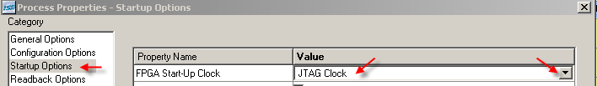
Step 4: Connect the LCD module to Nexys-3 board using upper-left two connectors (JA and JB)
Step 5: Download the bit file onto the FPGA using Adept and see how the demo works
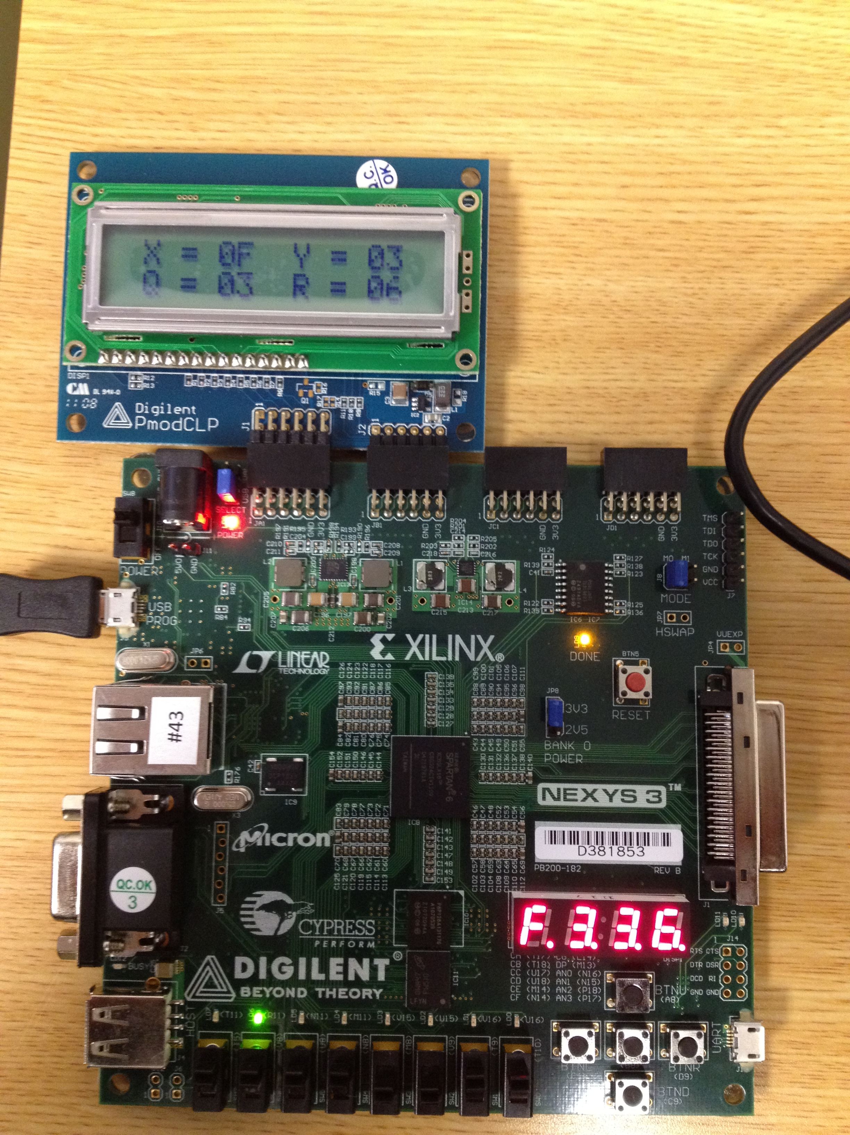

LCD core design
In this section, I will explain how the LCD core design works. Before beginning the explanation of the LCD core design, there is one thing to note:

** There is no need to change the LCD module. So if you’re not so sure, NEVER change it!
If the LCD module is not working in your project, it’s because either 1) your TOP design is wrong or 2) your UCF file does not contain JA and JB pin connectors description. **

The file lcd_core.v provides an initialization sequence and another sequence to display/update characters regularly. It is important to provide the initialization sequence when the LCD is turned on, in order to tell it that the TOP design is willing to send characters to the LCD module.

When the power is turned on, the LCD controller goes to the reset state. The following sequence of operation is performed to initialize the controller (Power On-> Set Function->Display Set->Display Clear). After the end of initialization we have to wait for at least 1.52 ms before sending the next instruction. Thereafter each instruction can be sent with a time difference of 40 μs between them.
Please see the figure below for more details.

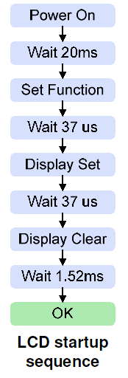

The file lcd_core.v has reset, clk inputs and 32 8-bit data inputs for 32 characters on two rows (data_f1 to data_s16).
And it has 8-bit lcd_data output, which is sent via JA pin connectors. The output lcd_data can be either a character to be displayed on the LCD or a command among the initialization sequence.

For more information, please read the manual provided by Digilent.
http://www.digilentinc.com/Data/Products/PMOD-CLP/PmodCLP_rm_RevA.pdf

